**Project Assignment 2**

Rui Zhu, Lingjing Huang, Entisar Seedi M Alshammry

**Part 1:**

|  |  |
| --- | --- |
| Conceptual Class Category | Name |
| Business transactions | Sale, Payment |
| Transaction line Items | SalesLineItem |
| Product | Item |
| Where is the transaction recorded? | Transaction System, Sale Activity System |
| Roles of people or organizations related to the transaction | Customer, Manager, Food Supply System, Administrator, Sales Activity System |
| Noteworthy event | Sale, Payment |
| Physical objects | Item |
| Descriptions of things | ProductDescription |
| Catalogs | ProductCatalogs |
| Other collaborating | CreditAuthorizedSystem |
| Financial Instruments | CashPayment |

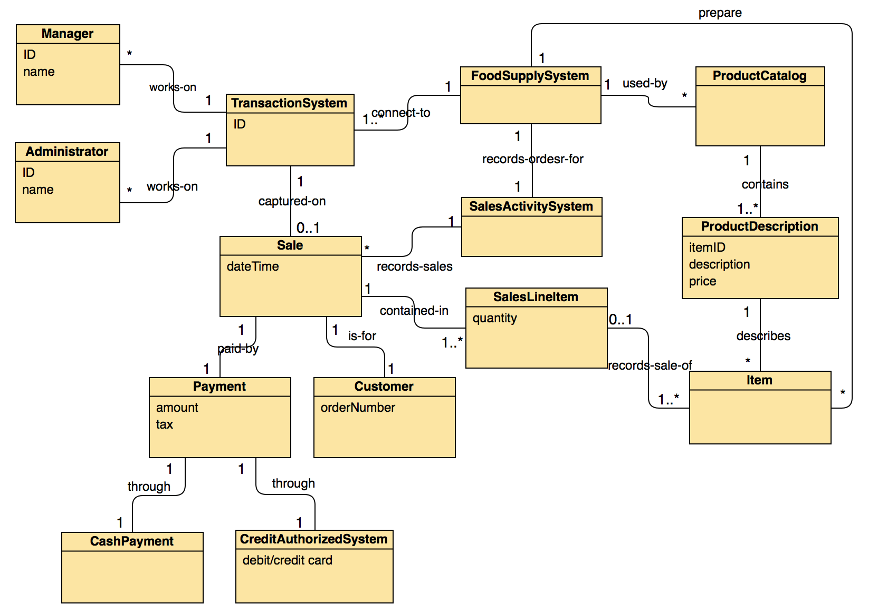

**Part 2:**

